### **Ensemble Techniques**

* **Core Idea:** Ensemble methods combine the predictions of multiple individual machine learning models (called ***base learners* or *weak learners***) to produce a single, often more accurate and robust, final prediction (*strong learner*).
* **Analogy:** Think of seeking advice from multiple experts instead of just one. By combining their opinions (predictions), you often arrive at a better decision.
* **Goal:** To improve the overall predictive performance (accuracy, robustness) compared to any single base learner used in the ensemble. They aim to reduce either the *bias* or the *variance* component of the prediction error, or both.

**2. Why Use Ensemble Techniques? (Advantages)**

* **Improved Accuracy:** Ensembles typically yield better performance than any single contributing model, especially if the base learners are diverse and their errors are somewhat uncorrelated.
* **Increased Robustness & Stability:** The final prediction is less sensitive to noise or outliers in the training data or the specific choice of training subset. This primarily comes from reducing variance.
* **Reduced Overfitting:** Techniques like Bagging are particularly effective at reducing variance and making the model generalize better to unseen data.
* **Bias Reduction:** Techniques like Boosting focus on reducing bias by iteratively correcting the mistakes of previous models.
* **Capturing Complex Patterns:** Different models might learn different aspects of the data. Combining them can lead to a more comprehensive understanding of the underlying patterns.

**3. Main Categories of Ensemble Techniques**

There are three main families of ensemble methods:

**a) Bagging (Bootstrap Aggregating)**

* **How it Works:**
  1. **Bootstrap Sampling:** Create multiple subsets of the original training dataset by sampling *with replacement* (meaning some data points may appear multiple times in a subset, while others might be omitted). Each subset is typically the same size as the original dataset.
  2. **Independent Training:** Train a separate base learner (usually of the same type, e.g., multiple decision trees) independently on each bootstrap sample.
  3. **Aggregation:** Combine the predictions of all base learners.
     + **Regression:** Average the predictions.
     + **Classification:** Use majority voting (or average predicted probabilities - soft voting).
* **Key Characteristic:** Parallel training of models on different data subsets.
* **Primary Goal:** Reduce **variance** and improve stability, making the model less sensitive to the specific training data.
* **Famous Example:** **Random Forest** (uses Decision Trees as base learners and adds an extra layer of randomness by considering only a random subset of features at each split).

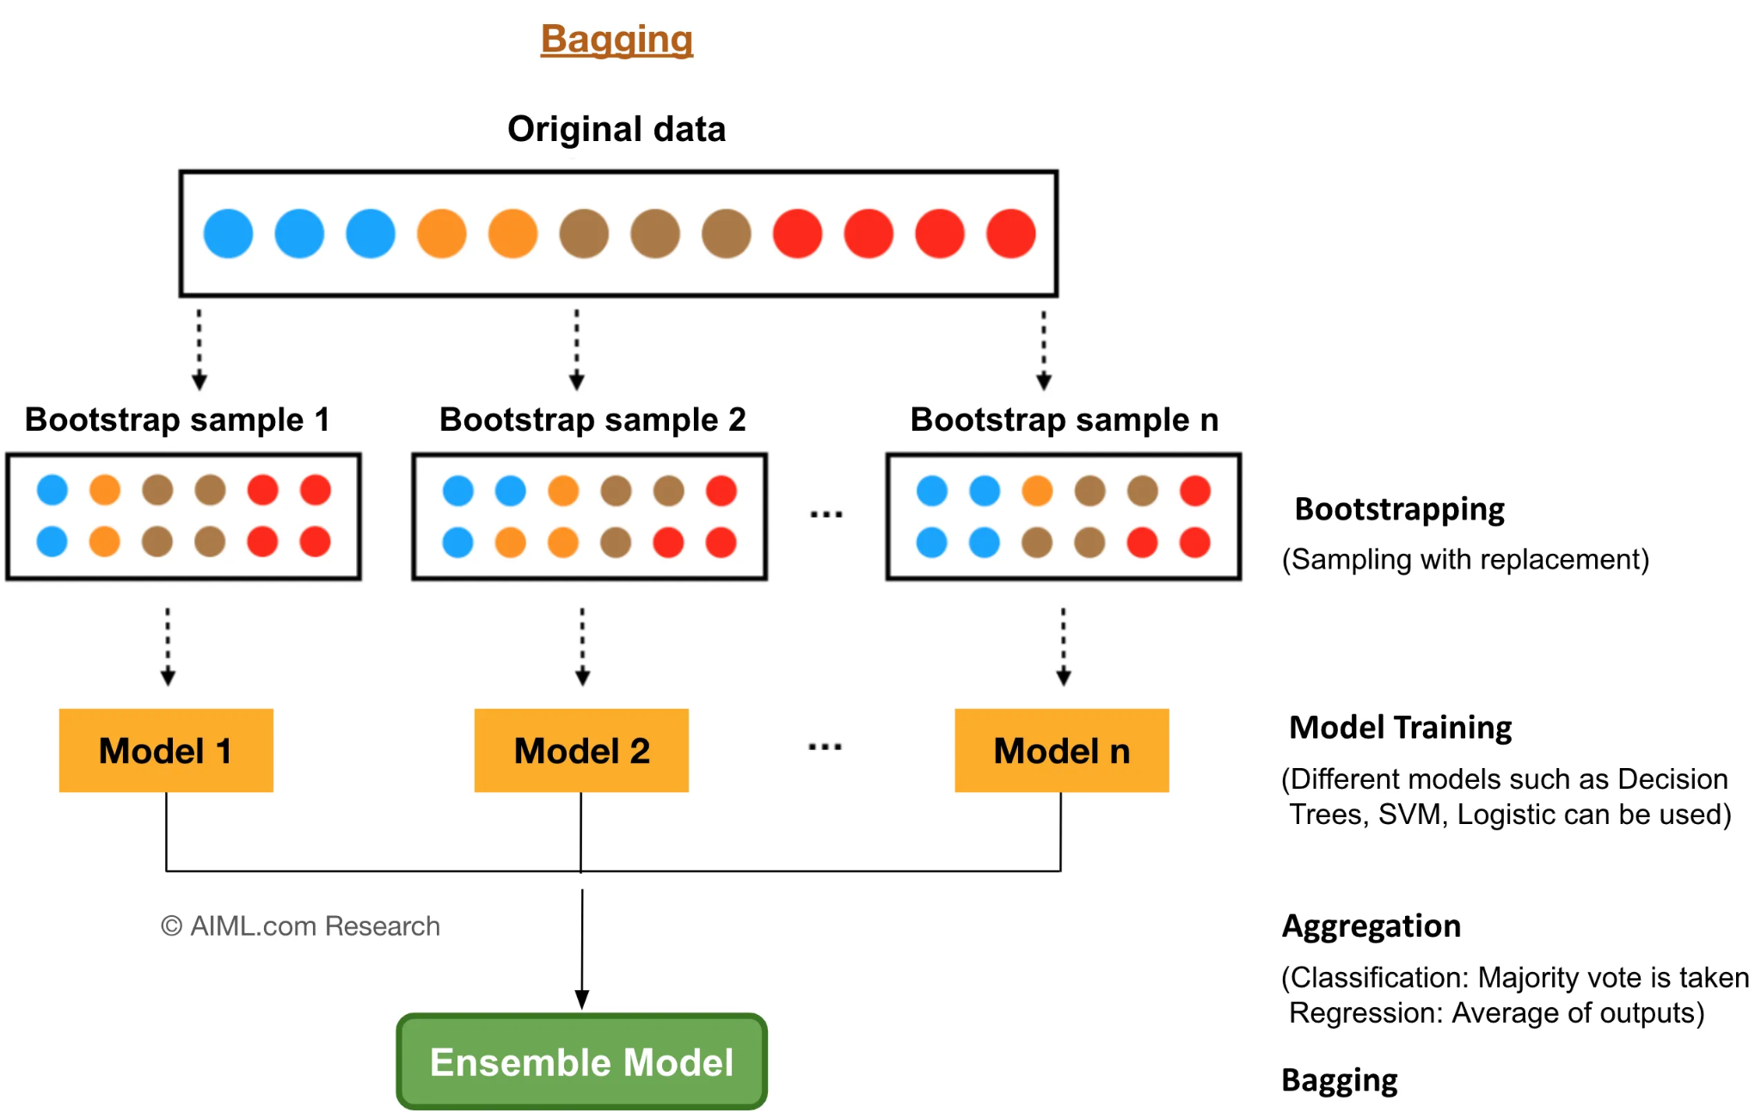

**b) Boosting**

* **How it Works:**
  + **Sequential Training:** Train base learners one after another in a sequence.
  + **Focus on Errors:** Each subsequent model pays more attention to the data points that were misclassified or had large errors by the previous models. This is often achieved by adjusting the weights of the training instances or by fitting subsequent models to the *residuals* (errors) of the previous ensemble.
  + **Weighted Aggregation:** Combine the predictions of all base learners, often giving more weight to the predictions of more accurate models.
* **Key Characteristic:** Sequential training, models learn from the mistakes of predecessors.
* **Primary Goal:** Reduce **bias** and often variance as well, turning a collection of weak learners into a strong learner.
* **Famous Examples:**
  + **AdaBoost (Adaptive Boosting):** Adjusts weights of training instances based on errors.
  + **Gradient Boosting Machines (GBM):** Sequentially fits models to the negative gradient (residuals) of the loss function.
  + **XGBoost (Extreme Gradient Boosting):** Optimized GBM with regularization, parallel processing capabilities, and handling missing values.
  + **LightGBM:** Faster GBM variant using gradient-based one-side sampling (GOSS) and exclusive feature bundling (EFB).
  + **CatBoost:** Handles categorical features effectively and uses ordered boosting to combat overfitting.

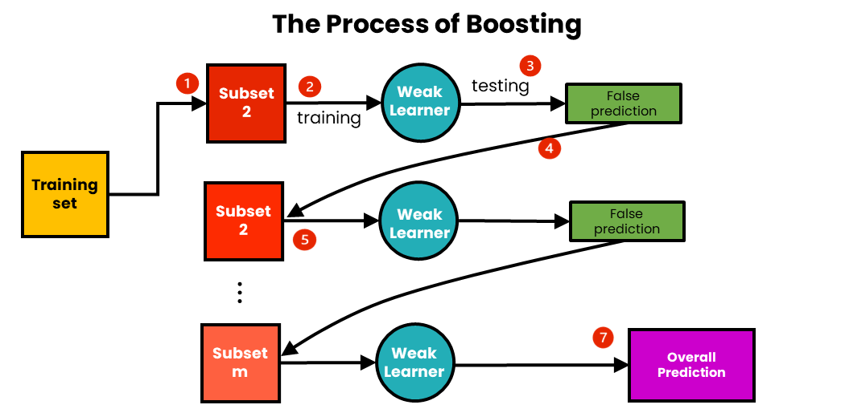

**c) Stacking (Stacked Generalization)**

* **How it Works:**
  1. **Train Base Learners:** Train multiple *different* types of base learners (e.g., an SVM, a KNN, a Decision Tree) on the original training data (often using cross-validation to generate predictions).
  2. **Generate Meta-Features:** Use the predictions made by these base learners as input features for a new, higher-level model called the *meta-learner* or *blender*.
  3. **Train Meta-Learner:** Train the meta-learner on these "meta-features" (the predictions of the base models). The target variable remains the original target variable.
  4. **Final Prediction:** The trained meta-learner makes the final prediction.
* **Key Characteristic:** Hierarchical structure; learns how to best combine the outputs of diverse base models.
* **Primary Goal:** Improve accuracy by leveraging the strengths of different modeling approaches.
* **Note:** Can be complex to implement correctly (requires careful handling of data splits, e.g., using k-fold cross-validation for generating base model predictions to avoid data leakage). *Blending* is a simpler variant often used in competitions.

**How Predictions are Combined**

* **Regression:**
  + **Averaging:** Simple average of predictions from all base learners.
  + **Weighted Averaging:** Average where predictions from better-performing models get higher weights.
* **Classification:**
  + **Majority Voting (Hard Voting):** Predict the class label that receives the most votes from the base learners.
  + **Weighted Voting:** Like majority voting, but votes from more accurate models count more.
  + **Soft Voting:** Average the predicted probabilities for each class across all base learners and predict the class with the highest average probability (often performs better than hard voting).

**6. Potential Disadvantages of Ensembles**

* **Reduced Interpretability:** It's harder to explain *why* an ensemble makes a particular prediction compared to a simpler model like a single decision tree or linear regression.
* **Increased Complexity:** Requires training and managing multiple models.
* **Higher Computational Cost:** Training time and resource usage are generally higher than for single models. Prediction time can also be longer.
* **Requires Careful Tuning:** Selecting base models, combining methods, and tuning hyperparameters can be more involved.

